UNIX SHELL PROGRAMMING
ASSIGNMENT
GROUP NO : 4[ROLL NOS:44-61]
Submitted By:
-Midhun K.P,44
-Minnu Baby,45
-Rahul Rajan,53
-Robin Vincent, 56
-SanilSaju, 57
-Sergis Jose, 59
-Thomas Paul, 60
-Yamuna S Soman, 61

B.TECH DEGREE EXAMINATION, MAY 2016
PART A

- List various kinds of UNIX files.
ANS:
Regular file - contain user data
  - Text Files
    - Characters drawn from the computers character set
  - Binary Files
    - Collection of data stored in the internal format of the computer
Directory files, directory file contains the name of other files and/or directories Directories have names just like other files, and these names obey the same naming rules as normal files.
A directory is used to store a record for each file or subdirectory it contains.
This record (also called directory entry) consists of the file inode number and the file name.
Special files (devices), it is a mean of accessing hardware device, including the keyboard, hard disk, CD-ROM drive…etc.
Each hardware device is associated with at least one special file.
-character
-block
-symbolic link
-FIFO
-Socket
2) Explain the use of tee utility.
ANS:
-copies standard input to standard output and at same time copies it in to one or more files
-create output files if they don’t exist and overwrites them if already exists
-to prevent files from overwritten, use –a option
-who | tee file1
3) Explain how devices are represented in UNIX.
ANS:
UNIX represents all devices as files. These files are located in the directory /dev. That is why the devices and other files are accessed in a similar way. Devices file which is specified as ‘block special file’ with some similar characters of a disk file. A device which is specified as a ‘character special file’ with some characteristics that is similar to a keyboard.
4) How will you count the no:of blank lines in a UNIX file?
ANS:
grep –c ‘^$’ file
5) What are zombies?
ANS:
Zombie Processes
- A process that terminates cannot leave the system until its parent accepts its return code.
- If its parent process is already dead, it’ll already have been adopted by the “init” process, which always accepts its children’s return codes.
- However, if a process’ parent is alive, but never executes a wait (), the child process’ return code will never be accepted and the process will remain a zombie

PART B
6) Explain the unix file system hierarchy?
ANS:
The UNIX file system is structured hierarchically upside down treelike, so it start with root directory and can have any number of files or sub directories under it. A typical UNIX system contains hundreds of files and directories, organized as the following:
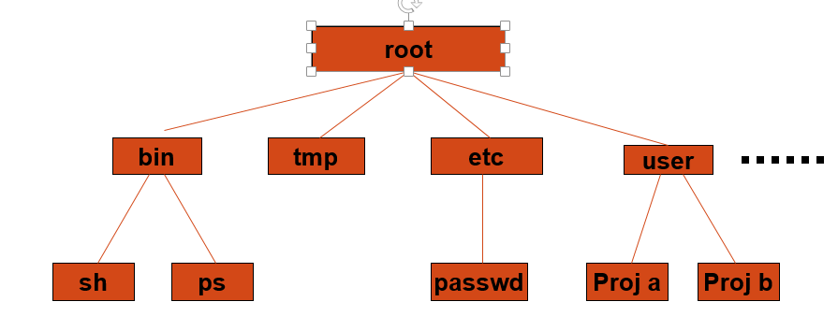 Root directory (/), at the top of the file system hierarchy and denote as a slash (/), it is the master cabinet which contains all.
/bin - it is known as binary directory, it contains binary -executables- including cat, kill, mv, rm, echo, date, mkdir, ksh, pwd...etc.
/dev - it is the device directory, contains files corresponding to the devices (terminals, disk drives..) connected to the computer. These are the special files mentioned earlier. Some files like lp (line printer), hd (hard drive), tty (terminal) are example of these files.
/etc - contains commands and files for system administration. A typical user not allowed to use these files and commands. Files in this directory include login, passwd, and profile.
/lib - contains a collection of related files for a given language in a single file called an archive. A typical UNIX system contains libraries for C, C++ and other languages. The archive file is used by application developed by that language. Some libraries are also stored in /usr/lib directory.
/lost+found- it contains all the files not connected to any directory. These files are found by a UNIX tool, fsck (file system check).
/tmp - it contains temporary files, all files are deleted periodically so the disk does not get filled with temp files.
/home - home directories for all users to store their personal files
/home/student
/usr- it may hold some directories which contains the UNIX utilities, tools, languages, libraries, and manual pages. Two of the most important sub directories in this directory are /bin and /lib.
/var - it contains log files(/var/log), emails(/var/mail), print queues(/var/spool)
7) Explain how security is implemented in UNIX, with examples.
ANS:
Unix security refers to the means of securing a Unix or Unix-like operating system. A secure environment is achieved not only by the design concepts of these operating systems, but also through vigilant user and administrative practices.

Permissions
A core security feature in these systems is the permissions system. All files in a typical Unix-style filesystem have permissions set enabling different access to a file.
Permissions on a file are commonly set using the chmod command and seen through the ls command. For example:-r-xr-xr-x 1 root wheel 745720 Sep 8 2002 /bin/sh

User groups
Users under Unix style operating systems often belong to managed groups with specific access permissions. This enables users to be grouped by the level of access they have to this system. Many Unix implementations add an additional layer of security by requiring that a user be a member of the wheel user privileges group in order to access the su command.

Root access
Most Unix and Unix-like systems have an account or group which enables a user to exact complete control over the system, often known as a root account. If access to this account is gained by an unwanted user, this results in a complete breach of the system. A root account however is necessary for administrative purposes, and for the above security reasons the root account is seldom used for day to day purposes (the sudo program is more commonly used), so usage of the root account can be more closely monitored.

Passwords
Selecting a strong password and guarding it properly are probably the most important things a user can do to improve Unix security. In Unix systems, the essential information about users is stored under the file /etc/passwd. This file keeps track of the users registered in the system and their main definitions. Passwords, or more correctly, the hash of the password, can also be stored in the same place. The entries in /etc/passwd occupy exactly one line each, and have the following form: nickname:password_hash:UserID:GroupID:Complete_Name:home_dir:shell_bin
8) Write a note on various editors in UNIX.
ANS:
vi editor:
- Use vi editor to:
    - create text files
    - edit text files
- Our Goal is to create and run a shell scripts
Vi is the visual editor on the Unix.Before vi the primary editor used on Unix was the line editor .User was able to see/edit only one line of the text at a time.
There are two modes in vi
  - Command mode
  - Input mode
When you start vi by default it is in command mode.You enter the input mode through various commands.You exit the input mode by pressing the Esc key to get back to the command mode.
Emacs: it is a popular text editor used mainly on Unix-based systems by programmers, scientists, engineers, students, and system administrators.Like other Unix text editors, Emacs provides typed commands and special key combinations that let you add, delete, insert, and otherwise manipulate words, letters, lines, and other units of text. Emacs is commonly used to enter the source statements for programs. Emacs itself is built using the lisp programming language and users are invited to extend or personalize it using the same language. Emacs also offers a number of convenient capabilities such as the ability to initiate a program compiler and to handle e-mail from within the editor.
jEdit : it is a text editor available under the unixsytems. It is written in Java and runs on any operating system with Java support, including BSD, Linux, macOS and Windows.jEdit includes syntax highlighting that provides native support for over 200file formats. Support for additional formats can be added manually usingXML files. It supports UTF-8 and many other encodings.
It has extensive code folding and text folding capabilities as well as text wrapping that takes indents into account.
The application is highly customizable and can be extended with macroswritten in BeanShell, Jython, JavaScript and some other scripting languages.

9)Give the uses of the commands: diff, uniq, cmp, head, nice.
ANS:
diff command:
diff analyzes two files and prints the lines that are different. Essentially, it outputs a set of instructions for how to change one file in order to make it identical to the second file.
It does not actually change the files; however, it can optionally generate a script (with the -e option) for the program ed (or ex which can be used to apply the changes)
Let's say we have two files, file1.txt and file2.txt.
If file1.txt contains the following four lines of text:
I need to buy apples.
I need to run the laundry.
I need to wash the dog.
I need to get the car detailed.
...and file2.txt contains these four lines:
I need to buy apples.
I need to do the laundry.
I need to wash the car.
I need to get the dog detailed.
...then we can use diff to automatically display for us which lines differ between the two files with this command:
diff file1.txt file2.txt
...and the output will be:
2,4c2,4
< I need to run the laundry.
< I need to wash the dog.
< I need to get the car detailed.
---
> I need to do the laundry.
> I need to wash the car.
> I need to get the dog detailed.
uniq command:
- uniq command in unix or linux system is used to suppress the duplicate lines from a file.
- It discards all the successive identical lines except one from the input and writes the output.
- The syntax of uniq command is
uniq [option] filename
INPUT FILE
cat example.txt
unix operating system
unix operating system
unix dedicated server
linux dedicated server
The default behavior of the uniq command is to suppress the
duplicate line. Note that, you have to pass sorted input to the
uniq, as it compares only successive lines.
uniq example.txt
unix operating system
unix dedicated server
linux dedicated server
Duplicate line is suppressed (marked red in input file)
compare (cmp) command
- The cmp (compare) command compares two files, character (byte) by character, and provides the location of the differences to the screen.
- Used with no options, cmp will only provide the location of the first discrepancy in the form of “char, line”.
- However, there are options that will provide you with more information.
- The “-l” option will provide you with a list of the byte number and the ASCII octal value of the differing bytes.
- -c
Output differing bytes as characters.
- -l
Write the byte number (decimal) and the differing bytes (octal) for each difference
INPUT FILE
cat file2.txt
My name is MohakKataria
cat file1.txt
My name is Mohak
- Compare file1 to file2 and outputs results
cmp file1.txt file2.txt
file1.txt file2.txt differ: byte 17, line 1
head command:
- The head command in unix or linux system is used to print the first N lines from the file to the terminal. The syntax of head command is
- head [options] [files]
INPUT FILE
cat example.txt
linux storage
ubuntuos
fedora
- By default, the head command prints the first 10 lines from a file.
- head example.txt
- Use the -n option to print the first n lines from a file. The following example prints the first 2 lines from the file:
head -n2 example.txt
linux storage
ubuntuos
nice command:
nice runs command COMMAND with an adjusted "niceness", which affects process scheduling. A process with a lower niceness value is given higher priority and more CPU time. A process with a higher niceness value (a "nicer" process) is given a lower priority and less CPU time, freeing up resources for processes which are more demanding.

nice syntax
nice [OPTION] [COMMAND [ARG]...]
10.)Write a note on signals in UNIX
Signals are software interrupts that are sent to program when an event happens.The events themselves might be request from users or indications that a system problem has occurred.
Sending Signals Using The Keyboard :
There are certain key presses that are interpreted by the system as requests to send signals to the process with which we are interacting:
->Ctrl-C Pressing this key causes the system to send an INT signal (SIGINT) to the running process.
Sending Signals From The Command Line:
Another way of sending signals to processes is done using various commands, usually internal to the shell:The kill command accepts two parameters:a signal name (or number).
Sending Signals Using System Calls:
A third way of sending signals to processes is by using the kill system call.This is the normal way of sending a signal from one process to another.

PART C

11. (a) Explain the word processing commands: nroff,troff.
ANS:
nroff
nroff and troff are UNIX commands (and the utilities that support them) for formatting text files for printing. (There are other UNIX commands for initiating printing.) nroff is designed for formatting output for line printers and letter-quality printers. troff is designed for formatting output for typesetters. troff contains some special functions that apply only to typesetters; otherwise, the commands are identical and either can be used.
In general, a text file designed for use with nroff or troff contains embedded codes for line spacing, margin settings, centering, tab stops, keeping lines together, and so forth. The command itself includes options that apply to the entire file. nroff and troff provide about the same level of formatting control as IBM's Script/VS language. In general, text formatting languages at this level have the drawback of making it difficult to reuse the text in a non-print medium (such as on the Web). This drawback led to the development of the non-output specific markup defined generally by Standard Generalized Markup Language in which a logical or functional description is applied to text elements that device-specific programs can interpret in an appropriate way.
Examples of nroff/troff formatting codes include:
.ce
Center the next lines of text.
.sp
Skip a line space.
.ps 10
Use 10-point type.
A popular UNIX replacement for nroff/troff is a formatter called TeX (pronounced "TEK"). TeX is designed to give the user a great deal of control over font choice and text arrangement and especially to support text containing mathematical symbols.
If you have inherited an nroff/troff file and need to convert it to HTML, you may be able to find a tool that will convert the file to HTML "preformatted" text (meaning that the file will look as though it has been brought in from somewhere). While this may be a temporary solution in some cases, it's likely that eventually you will have to strip the old codes and start with new formatting (using HTML tags) manually.
Troof
thetroff processor of the groff text formatting system
troff [ -abcivzCERU ] [ -d ] [ -f ] [ -F ] [ -m ] [ -M ] [ -n ] [ -o ] [ -r ] [ -T ] [ -w ] [ -W ] [ files... ]
It is possible to have whitespace between a command line option and its parameter. This manual page describes the GNU version of troff. It is part of the groff document formatting system. It is functionally compatible with UNIX troff, but has many extensions, see groff_diff(7). Usually it should be invoked using the groff(1) command which will also run preprocessors and postprocessors in the appropriate order and with the appropriate options.
(b) List the process related utilities in UNIX
ANS:
ps (process status):
Display some process attributes of currently running process
ps
PID TTY TIME CMD
1078 pts/2 0:00 bash
presents a snapshot of the process table.
ps -f
option displays a fuller listing that includes the PPID.
ps -u
option followed by user-id displays the processes owned by theuser-id.
ps -e
option displays the system processes.
kill
Terminating the process
SYNTAX:
kill -9 pid
top
This utility tells the user about all the running processes on the Linux machine.
OR
12. (a)Explain mount and unmount operations, with examples.
ANS:
The mount command mounts a storage device or filesystem, making it accessible and attaching it to an existing directory structure.
All files accessible in Unix, or a Unix-style system such as Linux, are arranged in one big tree: the file hierarchy, rooted at /. These files can be spread out over several devices. The mount command attaches a filesystem, located on some device or other, to the file tree. Conversely, the umount command will detach it again.
The standard form of the mount command is:
mount -t type device dir
The umount command detaches the specified file system(s) from the file hierarchy. A file system is specified by giving the directory where it has been mounted. Giving the special device on which the file system lives may also work, but is an obsolete method, mainly because it will fail in case this device was mounted on more than one directory.
Note that a file system cannot be unmounted when it is busy - for example, when there are open files on it, or when some process has its working directory there, or when a swap file on it is in use. The offending process could even be umount itself - for example, umount opens the common C libraries, which in turn may open (for example) locale files, which, if they are located on the device in question, will prevent it from being unmounted.
(b)List the file handling utilities in UNIX
ANS:

cp
Syntax: cpsourcefiledestfile
Makes a copy of sourcefile which is then named destfile

mv
Syntax: mv sourcefiledestfile
Renames, or moves sourcefile to destfile. For example, to rename mycopy to newcopy:

rm
Syntax: rm file
Removes file. For example, to remove newcopy:

cat
Syntax: cat file
The standard command with which to display a file.
more and less (display text with pause)
displays the contents of target-file(s) on the screen, pausing at the end of each screenful and asking the user to press a key (useful for long files). It also incorporates a searching facility (press '/' and then type a phrase that you want to look for).
$ more target-file(s)
You can also use more to break up the output of commands that produce more than one screenful of output as follows (| is the pipe operator, which will be discussed in the next chapter)
$ ls | more
less is just like more, except that has a few extra features (such as allowing users to scroll backwards and forwards through the displayed file). However less may not be present on all UNIX systems.
13. (a)Define regular expression. List regular expression operators with examples.
ANS:
RE is a pattern consisting of sequence of characters
RE is made of atoms and operators
An atom specifies what text is to be matched and where it is to be found.
An operator combines atoms in to complex expressions
RE is a pattern consisting of sequence of characters that is matched against text
UNIX evaluates text against the pattern to determine if the text and the pattern match
if they match, the expression is true and a command is executed
if they don’t ,the expression is false and a command is not executed

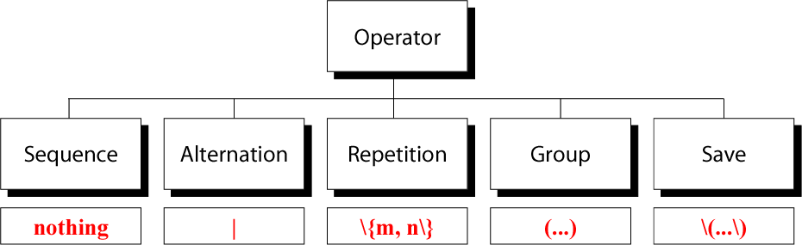

Sequence Operator
In a sequence operator, if a series of atoms are shown in a regular expression, there is no operator between them
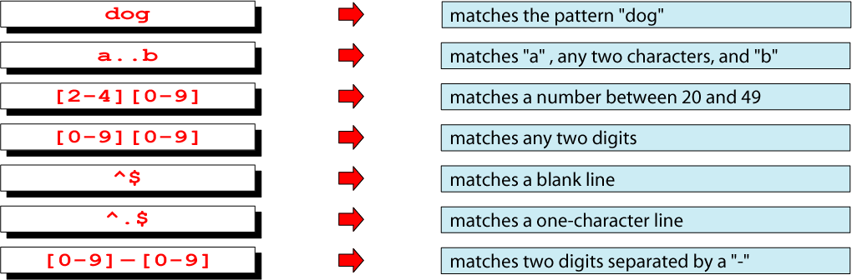
Alternation Operator: | or \|
operator (| or \| ) is used to define one or more alternatives


Repetition Operator: \{…\}
The repetition operator specifies that the atom or expression immediately before the repetition may be repeated.
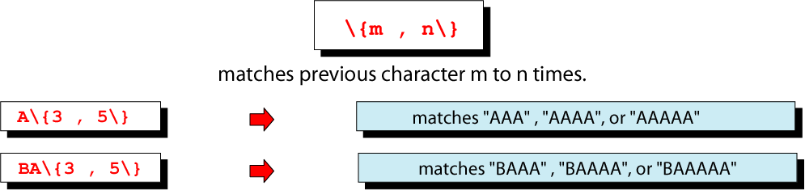
Group Operator
In the group operator, when a group of characters is enclosed in parentheses, the next operator applies to the whole group, not only the previous characters.
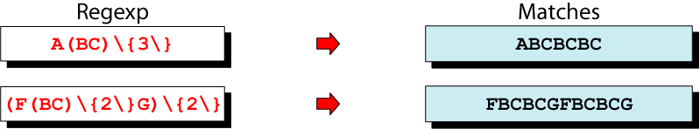
Save operator
set of escaped paranthesis, \(……\),copies a matched text string to one of the nine buffers for later reference .
(b).Give the uses of cut and paste commands, with examples.
ANS:
In computing, cut is a Unix command line utility which is used to extract sections from each line of input — usually from a file. It is currently part of the GNU coreutils package and the BSD Base System. It first appeared in AT&T System III UNIX in 1982.^{[1][better source needed]}
Extraction of line segments can typically be done by bytes (-b), characters (-c), or fields (-f) separated by a delimiter (-d — the tab character by default). A range must be provided in each case which consists of one of N, N-M, N- (N to the end of the line), or -M (beginning of the line to M), where N and M are counted from 1 (there is no zeroth value). Since version 6, an error is thrown if you include a zeroth value. Prior to this the value was ignored and assumed to be 1.
cut [-b list] [-c list] [-f list] [-n] [-d delim] [-s] [file]
Flags which may be used include
-b
Bytes; a list following -b specifies a range of bytes which will be returned, e.g. cut -b1-66 would return the first 66 bytes of a line. NB If used in conjunction with -n, no multi-byte characters will be split. NNB. -b will only work on input lines of less than 1023 bytes
-c
Characters; a list following -c specifies a range of characters which will be returned, e.g. cut -c1-66 would return the first 66 characters of a line
-f
Specifies a field list, separated by a delimiter
list
A comma separated or blank separated list of integer denoted fields, incrementally ordered. The - indicator may be supplied as shorthand to allow inclusion of ranges of fields e.g. 4-6 for ranges 4–6 or 5- as shorthand for field 5 to the end, etc.
-n
Used in combination with -b suppresses splits of multi-byte characters
-d
Delimiter; the character immediately following the -d option is the field delimiter for use in conjunction with the -f option; the default delimiter is tab. Space and other characters with special meanings within the context of the shell in use must be enquoted or escaped as necessary.
-s
Bypasses lines which contain no field delimiters when -f is specified, unless otherwise indicated.
file
The file (and accompanying path if necessary) to process as input. If no file is specified then standard input will be used.

paste is a Unix command line utility which is used to join files horizontally (parallel merging) by outputting lines consisting of the sequentially corresponding lines of each file specified, separated by tabs, to the standard output. It is effectively the horizontal equivalent to the utility cat command which operates on the vertical plane of two or more files.
For the following examples, assume that names.txt is a plain-text file that contains the following information:
Mark Smith
Bobby Brown
Sue Miller
Jenny Igotit
and that numbers.txt is another plain-text file that contains the following information:
555-1234
555-9876
555-6743
867-5309
The following example shows the invocation of paste with names.txt and numbers.txt as well as the resulting output:
$ paste names.txt numbers.txt
Mark Smith 555-1234
Bobby Brown 555-9876
Sue Miller 555-6743
Jenny Igotit 867-5309

OR
14 (a)Explain the use of pipes,with examples.
ANS:
pipe operator:
temporarily saves the output of one command in a buffer that is being used at the same time as the input of next command
pipe is an operator, not a command (|)
must be placed between two commands
the first command must be able to send its output to a standard output
the second command must be able to read its input from standard input
pipe receives its input from standard output and send it to next command through standard input
who | more
A pipe is designated in commands by the vertical bar character
command_1 | command_2 [| command_3 . . . ]

A very simple example of the benefits of piping is provided by the dmesg command, which repeats the startup messages that scroll through the console while Linux is booting.
dmesg by itself produces far too many lines of output to fit into a single screen; thus, its output scrolls down the screen at high speed and only the final screenful of messages is easily readable. However, by piping the output of dmesg to the filter less, the startup messages can conveniently be viewed one screenful at a time, i.e.,

dmesg | less

less allows the output of dmesg to be moved forward one screenful at a time by pressing the SPACE bar and back one screenful at a time by pressing the b key. The command can be terminated by pressing the q key. (The more command could have been used here instead of less; however, less is newer than more and has additional functions, including the ability to return to previous pages of the output).
(b)Explain the uses of sort command ,with examples.
ANS:
sort command
sort command in unix or linux system is used to order the elements or text. Sort command has the capability of sorting numerical values and strings. The sort command can order the lines in a text file.

The syntax of sort command is:
sort [options] filename

-b : Ignores leading spaces in each line
-d : Uses dictionary sort order. Conisders only spaces and alphanumeric characters in sorting
-f : Uses case insensitive sorting.
-M : Sorts based on months.
-n : Uses numeric sorting
-R : Sorts the input file randomly. -r : Reverse order sorting
-k : Sorts file based on the data in the specified field positions.
-u : Suppresses duplicate lines
-t : input field separator

INPUT FILE
cat order.txt
Unix distributed 05 server
Linux virtual 3 server
Unix distributed 05 server
Distributed processing 6 system

The default sort command uses alphabetical order (ASCII order) to sort the file. It treats each line as a string and then sorts the lines
sort order.txt
Distributed processing 6 system
Linux virtual 3 server
Unix distributed 05 server
Unix distributed 05 server

You can specify the field postions using the -k option of sort command. The sort command uses the space or tab as the default delimiter.
To sort based on the data in the second field, run the below command:
sort -k2 order.txt
Unix distributed 05 server
Unix distributed 05 server
Distributed processing 6 system
Linux virtual 3 server

Instead of the default alphabetical sorting order, you can make the sort command to sort in numeric order using the -n option. This is shown below:
sort -nk3 order.txt
Linux virtual 3 server
Unix distributed 05 server
Unix distributed 05 server
Distributed processing 6 system
//[ third field numeric sorting]

the sort command sorts the data in ascending order. You can change this to descending order using the -r option.

sort -nrk3 order.txt
Distributed processing 6 system
Unix distributed 05 server
Unix distributed 05 server
Linux virtual 3 server
// numeric sorting field three in reverse order

Suppressing duplicates or Print only unique values

sort -u order.txt
Distributed processing 6 system
Linux virtual 3 server
Unix distributed 05 server
15) Explain the use of awkcommand ,with suitable examples.
ANS:
- Awk is used for processing text files, particularly data files that are organized by rows and columns.
Basic awk Syntax:
- awk ‘pattern{action}’ inputfile
- awk –f scriptfile.awkinputfile
Options:
-F to change input field separator
-f to name script file
awk operation:
  - scans a file line by line
  - splits each input line into fields
  - compares input line/fields to pattern
  - performs action(s) on matched lines

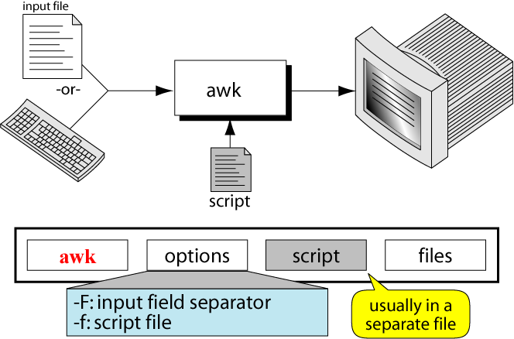

- awk scripts are divided into three major parts:
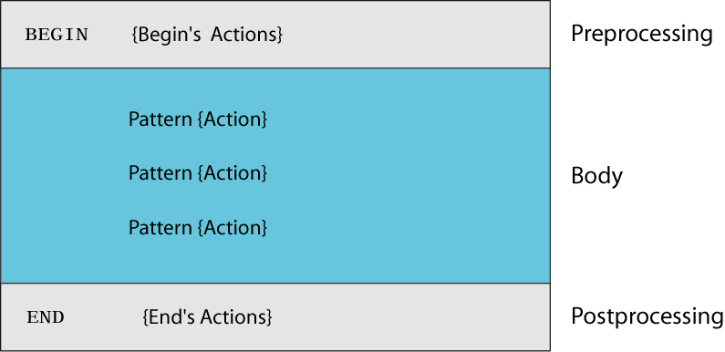
- comment lines start with #
awk operation:
  - scans a file line by line
  - splits each input line into fields
  - compares input line/fields to pattern
  - performs action(s) on matched lines
awk operation example:
BEGIN { print “totals” }
{
total = $1 + $2 + $3
print $1 “ +” $2 “+” $3 “=“ total
}
END { print “total completed”}
Example: match input record
% cat employees2
Tom Jones:4424:5/12/66:543354
Mary Adams:5346:11/4/63:28765
Sally Chang:1654:7/22/54:650000
Billy Black:1683:9/23/44:336500
% awk –F: '/00$/' employees2
Sally Chang:1654:7/22/54:650000
Billy Black:1683:9/23/44:336500
Example: explicit match
% cat datafile
northwest NW Charles Main 3.0 .98 3 34
western WE Sharon Gray 5.3 .97 5 23
southwest SW Lewis Dalsass 2.7 .8 2 18
southern SOSuan Chin 5.1 .95 4 15
southeast SE Patricia Hemenway 4.0 .7 4 17
eastern EA TB Savage 4.4 .84 5 20
northeast NE AM Main 5.1 .94 3 13
north NO Margot Weber 4.5 .89 5 9
central CT Ann Stephens 5.7 .94 5 13
Examples: matching with Res
% awk '$2 !~ /E/{print $1, $2}' datafile
northwest NW
southwest SW
southern SO
north NO
central CT
Other examples:
% awk '$3 * $4 > 300 {print $0}' file
awk ‘$1 == “susan” {print}’ file
% awk '($3>5) && ($4>30){print $0}' file
Print example:
% date
Wed Nov 19 14:40:07 CST 2008
% date |
awk '{print "Month: " $2 "\nYear: ", $6}'
Month: Nov
Year: 2008
Summary: awk program:
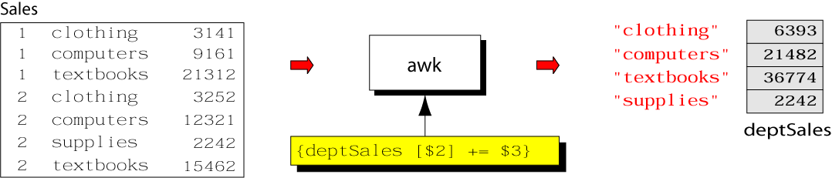

Example: complete program
% cat sales.awk
{
deptSales[$2] += $3
}
END {
for (x in deptSales)
print x, deptSales[x]
}
% awk –f sales.awk sales

OR
16 (a) Compare sed with ed command.
ANS:
The main difference between sed and ed is that sed is a stream editor while ed is line-oriented text editor.
sed:
- sed scans the input file, line by line, and applies a list of instructions(sed script) to each line in the input file.
- the script ,which is usually a separate file, can be included in the sed command line if it is a one line command
- it does not change anything in the original file
sed script:
- sed requires one or more instructions that provides the editing criteria
- when there is only one command, it may be entered from the keyboard
- mostly instruction are placed in a file(sed script)
- each instruction in a sed script contains an address and a command
sed script format:
- instructions included in command line
sed -e ‘address command’ input _file
- instructions placed in a file
sed –f script.sed input _file
create script file using text editor
save file with .sed extension
sed commands:
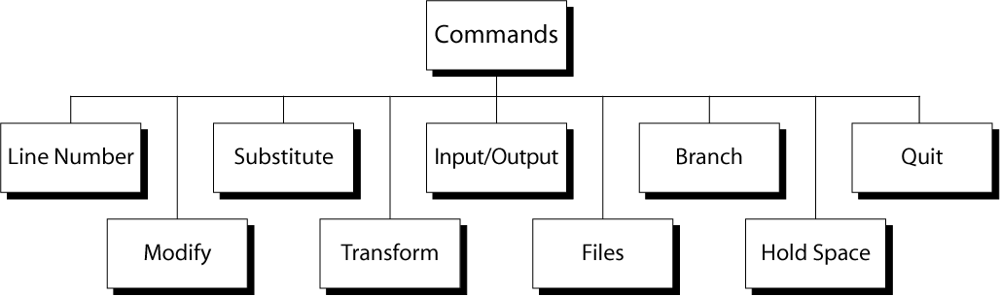

ed:
ed is a line-oriented text editor. It is used to create, display, modify and otherwise manipulate text files. red is a restricted ed: it can only edit files in the current directory and cannot execute shell commands.
If invoked with a file argument, then a copy of file is read into the editor’s buffer. Changes are made to this copy and not directly to file itself. Upon quitting ed, any changes not explicitly saved with a ‘w’ command are lost.
Editing is done in two distinct modes: command and input. When first invoked, ed is in command mode. In this mode commands are read from the standard input and executed to manipulate the contents of the editor buffer. A typical command might look like:
,s/old/new/g
which replaces all occurences of the string old with new.
When an input command, such as ‘a’ (append), ‘i’ (insert) or ‘c’ (change), is given, ed enters input mode. This is the primary means of adding text to a file. In this mode, no commands are available; instead, the standard input is written directly to the editor buffer. Lines consist of text up to and including a newline character. Input mode is terminated by entering a single period (.) on a line.
All ed commands operate on whole lines or ranges of lines; e.g., the ‘d’ command deletes lines; the ‘m’ command moves lines, and so on. It is possible to modify only a portion of a line by means of replacement, as in the example above. However even here, the ‘s’ command is applied to whole lines at a time.
In general, ed commands consist of zero or more line addresses, followed by a single character command and possibly additional parameters; i.e., commands have the structure:
[address [,address]]command[parameters]
The address(es) indicate the line or range of lines to be affected by the command. If fewer addresses are given than the command accepts, then default addresses are supplied.

(b) ) Explain grep command.
ANS:
global regular expression print:
- used to search the input file for all lines that match a specified regular expression and write them to the standard output
grep operation:
- for each line in the standard input file, grep performs the following operations
- copies next input to the pattern space. pattern space is a buffer that can hold one line of text
- applies the regular expression on that line
- if there is a match, the line is copied from the pattern space to the output
- grep utilities perform these three operations on each line in the input

- grep is a search utility.
- it can search only for the existence of a line that matches a regular expression
- if a line matches with regular expression, it is send to the output
- if the line does not match the RE , it is not printed
- the line selection is based on the RE
- grep is a filter
- grep cannot be used to add, delete or change a line
- grep cannot be used to print only a part of a line
- grep cannot read only a part of a file
- grep cannot select a line based on the contents of previous or next line
grep family:
- three utilities in grep family
- fastgrep – supports only string patterns. no RE
- grep – supports only a limited number of RE
- extended grep - supports most of the RE.but not all of them
grep family options:

options | explanation
-b | precedes each line by the file block number in which the match is found
-c | prints only a count of number of lines matching the pattern
-i | ignores uppercase or lowercase
-l | prints list of files that contain at least one line matching the pattern
-n | shows the line number of each line before the line
-v | inverse output. print lines that do not match the pattern
-x | print only lines that entirely match pattern
-f file | list of string that are to be matched are in file

Example:
search for file content specific directory
- To find a list of all files in current directory that contain a pattern
- the l options prints out the filename of any file that has at least one line that matches the grep expression
- grep –l ‘pattern’ *
17 (a) Explain the use of make command , with examples.
ANS:

make is a utility for building and maintaining groups of programs (and other types of files) from source code.

The purpose of the make utility is to determine automatically which pieces of a large program need to be re-compiled, and issue the commands necessary to recompile them.
This documentation describes the GNU implementation of make, which was written by Richard Stallman and Roland McGrath, and is currently maintained by Paul Smith.
Many of the examples listed below show C programs, since they are most common, but you can use make with any programming language whose compiler can be run with a shell command.
In fact, make is not limited to programs.
You can use it to describe any task where some files must be updated automatically from others whenever the others change.

make syntax

make [ -f makefile ] [ options ] ... [ targets ] ...

Options

-b, -m These options are ignored, but included for compatibility with other versions of make.
-B, --always-make Unconditionally make all targets.
-C dir, --directory=dir Change to directory dir before reading the makefiles or doing anything else.
If multiple -C options are specified, each is interpreted relative to the previous one: -C / -C etc is equivalent to -C /etc.
This is typically used with recursive invocations of make.
-d Print debugging information in addition to normal processing.
The debugging information says which files are being considered for remaking, which file-times are being compared and with what results, which files actually need to be remade, which implicit rules are considered and which are applied; everything interesting about how make decides what to do.
--debug[=FLAGS] Print debugging information in addition to normal processing.
If the FLAGS are omitted, then the behavior is the same as if -d was specified. FLAGS may be a for all debugging output (same as using -d), b for basic debugging, v for more verbose basic debugging, i for showing implicit rules, j for details on invocation of commands, and m for debugging while remaking makefiles.
-e, --environment-overrides Give variables taken from the environment precedence over variables from makefiles.
-f file, --file=file, --makefile=file Use file as a makefile.
-i, --ignore-errors Ignore all errors in commands executed to remake files.

(b) Write a shell script to find the largest of three given integers.
ANS:
echo “enter three numbers”
read a
read b
read c
if [$a –gt $b]
then
if [$a –gt $c]
then
echo “$a is large”
else
echo “$c is large”
fi
else
if [$b –gt $c]
then
echo “$b is large”
else
echo “$c is large”
fi
fi

OR
18) Write a shell script to print the sum of digits of a given number?

Ans:
# !/bin/ksh
a=$1
sum=0
while((a>0))
do
((d=a%10))
(( sum=sum+d))
((a=a/10))
done
print sum
19 (a) Explain the configuration of squid proxy server
ANS:
- Squid is a Unix-based proxy server that caches Internet content closer to a requestor than its original point of origin.
- Caching frequently requested Web pages, media files and other content accelerates response time and reduces bandwidth congestion.
- A Squid proxy server is generally installed on a separate server than the Web server with the original files.
- Squid works by tracking object use over the network. Squid will initially act as an intermediary, simply passing the client's request on to the server and saving a copy of the requested object.
- If the same client or multiple clients request the same object before it expires from Squid's cache, Squid can then immediately serve it, accelerating the download and saving bandwidth.

(b) Explain uses of fork() and exec() functions.
ANS:
Fork()
- The child process is an almost exact duplicate of the original parent process.
- The parent and child have different process ID numbers.
- If fork () succeeds, it returns the PID of the child to the parent process and returns 0 to the child process.
- If fork () fails, it returns -1 to the parent process and no child is created.
Example
#include <stdio.h>
main ()
{
intpid;
printf (“I’m the original process with PID %d and PPID %d.\n”),
getpid (), getppid ());
pid = fork (); /* Duplicate. Child and parent continue from here */
if (pid != 0) /* pid is non-zero, so I must be the parent */
{
printf (“I’m the parent process with PID %d and PPID %d.\n”,
getpid (), getppid ());
printf (“My child’s PID is %d\n”, pid);
}
else
{
printf (“I’m the child process with PID %d and PPID %d.”,
getpid (), getppid ());
}
printf(“PID %d terminates.\n”, getpid () ); /* Both processes execute
this */
}

output
I’m the original process with PID 13292 and PPID
13273.
I’am the parent process with PID 13292 and PID
13273.
My child’s PID is 13293.
I’m the child process with PID 13293 and PPID
13292.
PID 13293 terminates. PID 13292 terminates.

Exec()

- A process may replace its current code, data and stackwith those of another executable file by using one of the exec () family of system calls.
- When a process executes an exec (), its PID and PPIDnumbers stay the same – only the code that the processis executing changes.

Execl()
- intexecl (const char* path, const char* arg0, constchar* arg1,…,const char* argn, NULL)

- execl takes full path name of the command and variable length of arguments terminated by NULL

- execl(“/bin/ls”, “/bin/ls”, “-a”, “-l”, NULL)

Execlp()

- execlp will try to find the command from the $PATH .so full path to the command is not needed
- execlp(“ls”, ”ls” , “-a”, “-l”, NULL)

Execv()

    - intexecv (const char* path, const char* argv[])

    - execv() is equivalent to execl , except that the arguments are passed in as a null terminated array

    - char *args[]={“/bin/ls”, “-a”, “-l”, NULL}

    - execv(“/bin/ls”, args);

Execvp()

- execv() is equivalent to execlp , except that the arguments are passed in as a null terminated array

- char *args[]={“ls”, “-a”, “-l”, NULL}

- execv(“ls”, args);

OR
20) Explain X window systems. How is it started and stopped?
ANS:
- The X Window System was specifically designed to allow the graphical output of a program running on one machine to appear on a different machine
- A machine running an X windowing system can launch a program on a remote computer
- All the CPU processing happens on the remote computer but the display of the application appears on the local machine
- In 1984, the Massachusetts Institute of Technology released the X Windows System.
The X Architecture:
- When MIT started working on the project, they were aware that people were working with several types of graphic displays.
- Every display had its own methods for drawing lines and shapes on the screen
- If an application were to write to all these displays, then there had to be several versions of the application – one for each type of display
- It is not a good idea to design a hundred versions of a program for so many displays
- MIT decided that the display should be handled by a separate program
- The application would instead send its output to this display-handling program.
- This led to a very important splitting of the application into client and server components.
- In a typical Windows application, the job of handling the PC’s display is handled by the client application itself
- X reverses this paradigm and its architecture places the responsibility of handling the display on the server
- The application itself runs as a client.
- The X server and clients may be on the same machine, but X shines when they are separated and was primarily designed to run over a TCP/IP network.
- The transmission is totally reliable; X uses the TCP protocol.
- X technology lets you run an X client on a remote machine and yet have the display on your own local machine
- A basic X Window System concept is the separation of applications from the software that handles terminal input and output.
- All interactions with terminal devices are managed by a dedicated program (the server) where as applications (clients) send the server the information to be displayed.
Starting and Stopping X:
- Most systems will automatically start the X Window System with the command xdm from /etc/inittab.
- On systems that don’t start an X server for you at login time, there is usually a command such as xinit or startx that you can either type manually add to your login or profile script so that it will be started automatically when you log in.
- The xinit program will read the .xinitrc to configure itself when it is started.
- There is no standard way of quitting the X. One method is to point the cursor anywhere on the desktop or an edge of the screen and press one of the mouse buttons.
- If this brings up a menu, see if there is an option like “Exit Session” or “Log out”. The other method is for sessions started with xinit
- it may be possible to use the exit command in that xterm window seen on starting X.
X Clients and Display:
- There are a number of X clients, the most common being xterm, xclipboard and xclock.
- xterm
- The xterm is the most important X client. It comes up when X is started with xinit. Xterm behaves like any character-based terminal. An xterm window is an instance of the shell.

